- The Aero 2 system
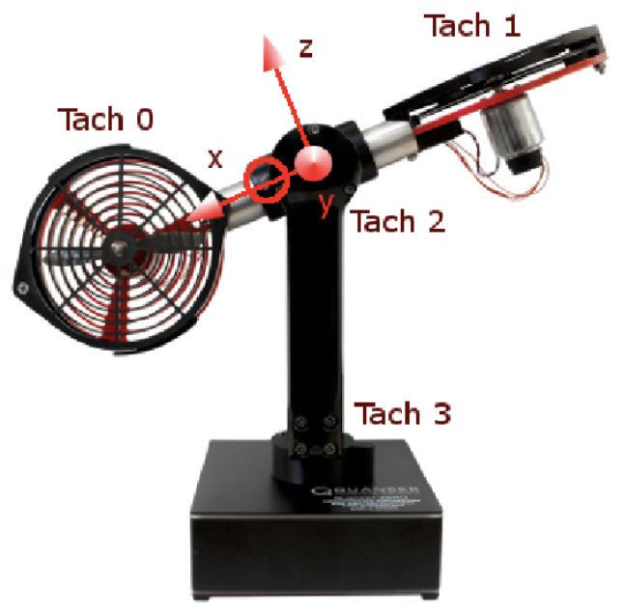Figure 1. Numbering of encoder, tach sensor
Encoder 2: 2048 pulses in mode quadrature (512 pulses)
Encoder 3: 4096 pulses per revolution in mode quadrature

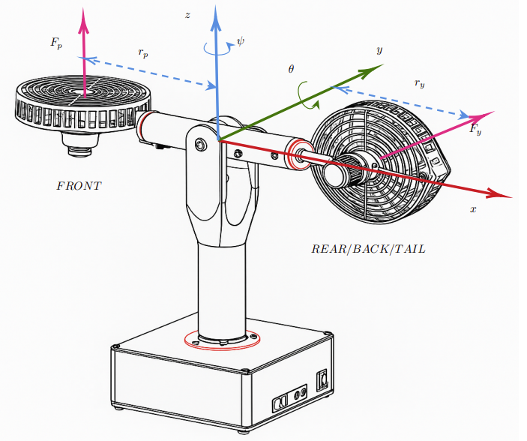Figure 2. Aero 2 with axis definition

Motor 1 (front)
Negative voltage : CW rotation, downward force
Positive voltage : CCW rotation, upward force

Motor 2 (back/tail)
Negative voltage : CCW rotation, downward force
Positive voltage : CW rotationn, upward force

1.3.2 Pilotage du Quanser Aero
The Aero rotate counter clockwise when supplying 10V to motor 1 (rotate CCW), -10V to motor 2 (rotate CCW)

1.3.3 Mesuring angle from yaw encoder
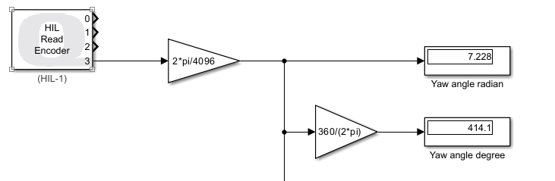

1.4 Estimate and filter angular yaw speed

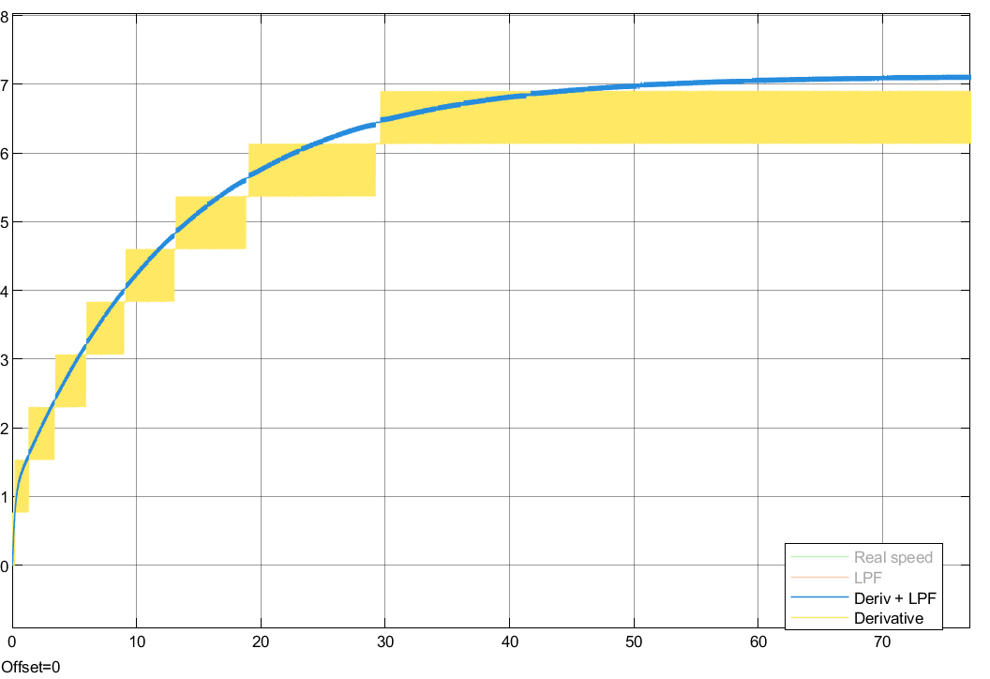
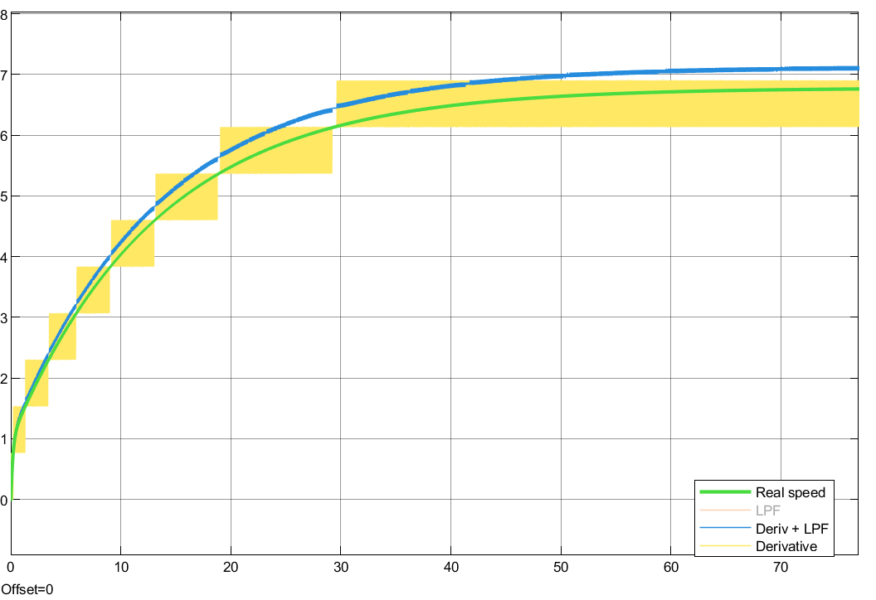Figure 3: Lowpass filter frequency 50 rad/s
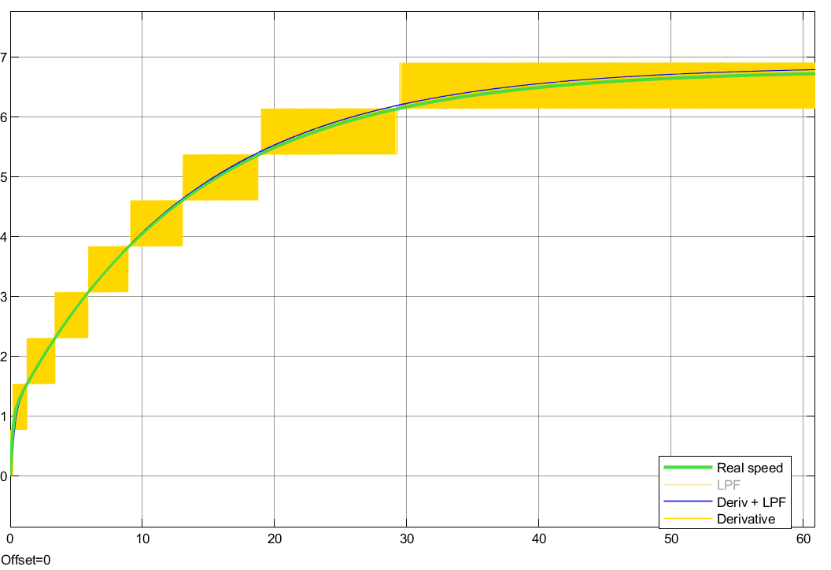
Figure 4: Lowpass filter frequency 10 rad/s

Effect of changing the cut frequency of low-pass filter:
Higher frequency: worse at estimating the real speed, let some noise pass through
Lower frequency: better at estimating the real speed but it could cause loss of informartion

2. Stabilize the yaw position for a system of 2 rotors

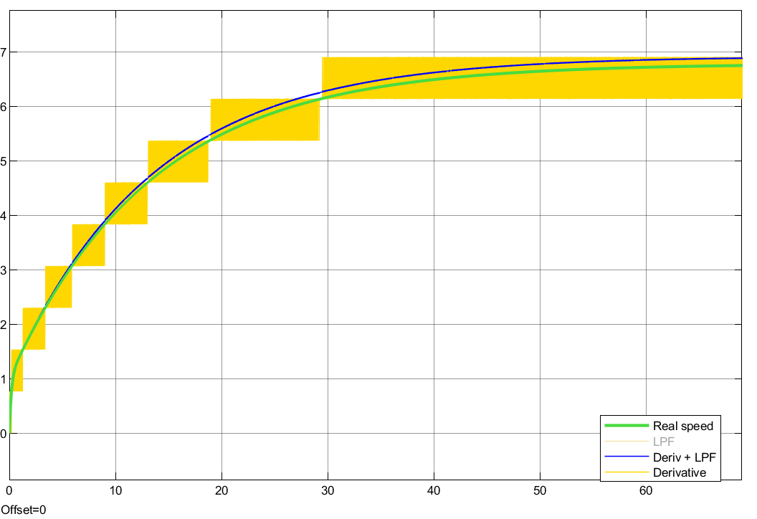Figure 5: Low-pass filter frequency 20 rad/s
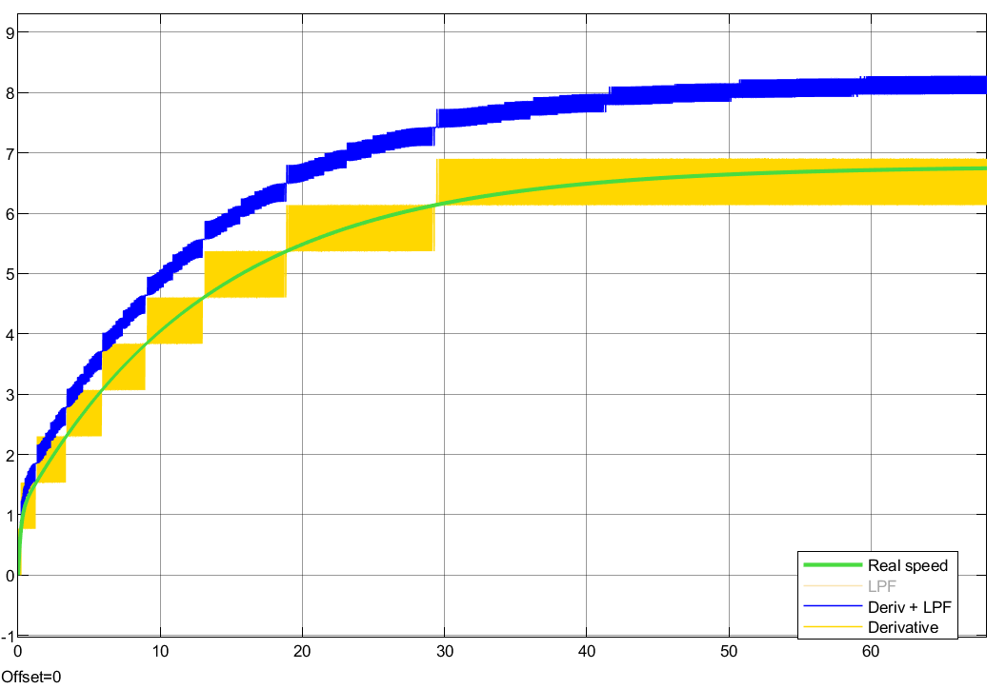Figure 6: Lowpass filter frequency 200 rad/s

